IT 2110 – Android Mobile App Development   
**Lab 5 –** **Worker Threads**

**Description:**Writing responsive apps

**Instructions:**

1. In your own words, explain when you would use 1. AsyncTask vs. 2. View.post() vs. 3. IntentService to run statements in a worker thread . [6 points]
2. Using the code from this week’s reading assignment (note: full code towards the end of the chapter). Modify each call, so that it runs a random amount of time (use <http://developer.android.com/reference/java/util/Random.html>). When complete, display the value of the amount of time that it took. Note: just display the value of the random number….you do not need to set a timer. [12 points]
3. **Deliverables:**Please submit screenshots in this document after each question. Take screenshots of your editor window and the app running on your computer.

This is the Random number generator method that returns a random number

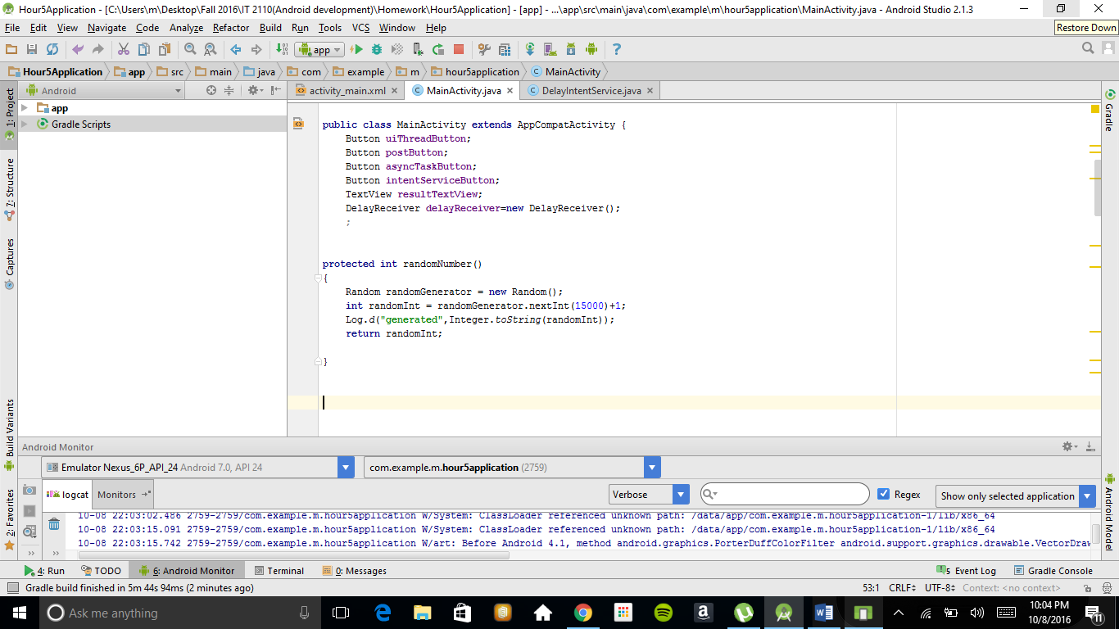

Then we just call this method when we need a random number

